**SQL Queries**

1) Write a query for the HR department to produce the addresses of all the departments.

Use the LOCATIONS and COUNTRIES tables. Show the location ID, street address,

city, state or province, and country in the output. Run the query



mysql> SELECT location_id, street_address, city, state_province, country_name

-> FROM locations

-> JOIN countries

-> ON(locations.country_id=countries.country_id);

2) The HR department needs a report of employees in Toronto. Display the last name, job,

department number, and department name for all employees who work in Toronto.



mysql> SELECT last_name, job_id, employees.department_id, department_name

-> FROM employees

-> JOIN departments

-> ON (employees.department_id=departments.department_id)

-> JOIN locations

-> ON (departments.location_id=locations.location_id)

-> WHERE city = "Toronto";

3) Create a report for HR that displays the last name and salary of every employee who reports to

King.



mysql> SELECT last_name, salary

-> FROM employees

-> WHERE manager_id = (SELECT employee_id

FROM employees

WHERE last_name LIKE "King");

4) Create Table MY_EMPLOYEE. Description is shown below:

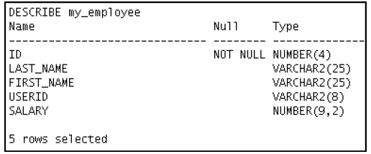

CREATE table my_employees(

emp_id INT NOT NULL,

last_name VARCHAR(25),

first_name VARCHAR(25),

user_id VARCHAR(8),

salary int(9)

);

5) Add the following data to the MY_EMPLOYEE table

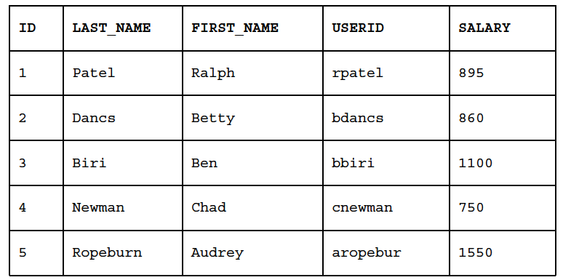

mysql> INSERT INTO my_employees

-> (emp_id, last_name, first_name, user_id, salary)

-> VALUES

-> (1,"Patel","Ralph","rpatel",895);

Query OK, 1 row affected (0.01 sec)

mysql> INSERT INTO my_employees

-> (emp_id, last_name, first_name, user_id, salary)

-> VALUES

-> (2,"Dancs","Betty","bdancs",860);

Query OK, 1 row affected (0.00 sec)

mysql> INSERT INTO my_employees

-> (emp_id, last_name, first_name, user_id, salary)

-> VALUES

-> (3,"Biri","Ben","bbiri",1100);

Query OK, 1 row affected (0.00 sec)

mysql> INSERT INTO my_employees

-> (emp_id, last_name, first_name, user_id, salary)

-> VALUES

-> (4,"Newman","Chad","cnewman",750);

mysql> INSERT INTO my_employees

-> (emp_id, last_name, first_name, user_id, salary)

-> VALUES

-> (5,"Ropeburn","Audrey","aropebur",1550);

mysql> select * from my_employees;

6) Change the last name of employee 3 to Drexler.

mysql> UPDATE my_employees

-> SET last_name = "Drexler"

-> WHERE emp_id = 3;

7) Change the salary to $1,000 for all employees who have a salary less than $900.

mysql> UPDATE my_employees

-> SET salary = 1000

-> WHERE salary<900;

Query OK, 3 rows affected (0.00 sec)

Rows matched: 3 Changed: 3 Warnings: 0

8) Delete Betty Dancs from the MY_EMPLOYEE table.

mysql> DELETE FROM my_employees

-> WHERE emp_id=2;

Query OK, 1 row affected (0.00 sec)

9) Mark an intermediate point in the processing of the transaction.

mysql> START TRANSACTION;

Query OK, 0 rows affected (0.00 sec)

mysql> SAVEPOINT step_10;

10) Delete all the rows from the MY_EMPLOYEE table. Confirm that the table is empty.

mysql> DELETE from my_employees;

11) Discard the most recent DELETE operation.

mysql> ROLLBACK TO step_10;

12) Make the data addition permanent.

mysql> COMMIT;

13) The staff in the HR department wants to hide some of the data in the EMPLOYEES table. Create

a view called EMPLOYEES_VU based on the employee numbers, employee last names, and

department numbers from the EMPLOYEES table. The heading for the employee name should be

EMPLOYEE.

Confirm that the view works. Display the contents of the EMPLOYEES_VU view

mysql> CREATE VIEW employee_vu

-> AS SELECT employee_id, last_name AS employee, department_id

-> FROM employees;

Query OK, 0 rows affected (0.02 sec)

mysql> select * from employee_vu;